Speed Up Magento

Loading Time of a website is e-commerce today is one of the important factors, determining the success of the site. The majority of users do not like to return to a website and run slow as tortoise. Your website is one of them

There are many reasons for E-Commerce Website using source Magento code to run slow. Here is one of the cause of your website running slow:

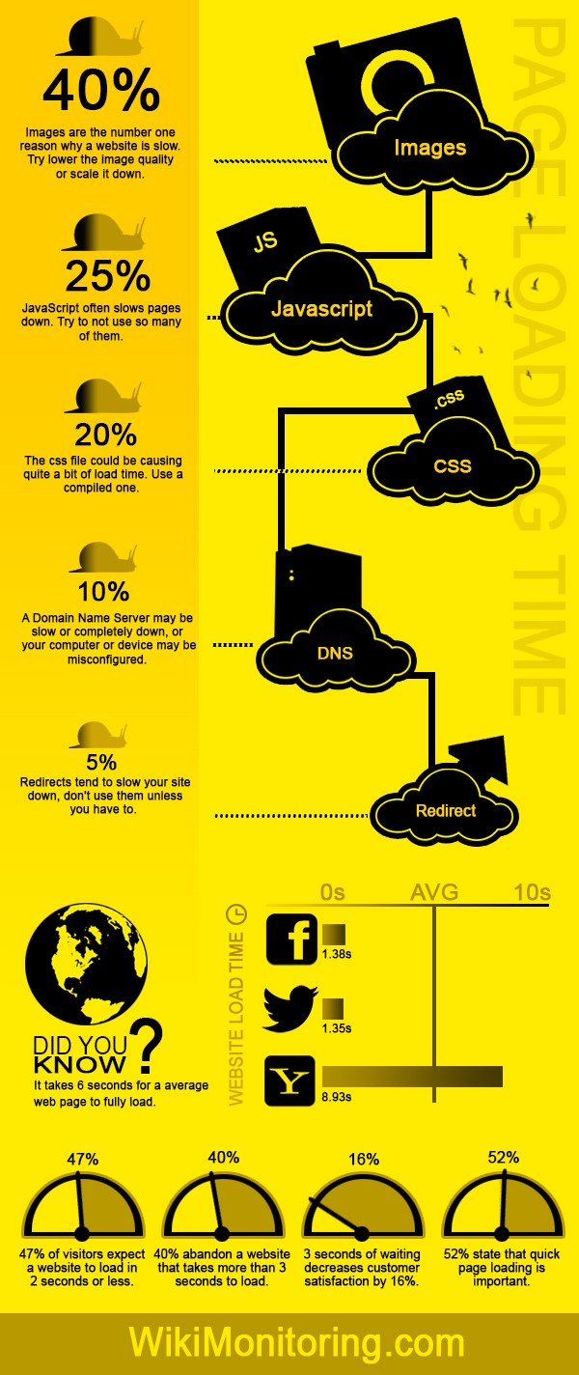

Here is one of the ways that you can refer to optimize your magento website system can speed up improvement in loading speed of your site:

1. Enable Flat Categories and Products.

One of the main problems that slow down magento 2 speed is the read speed of database; especially, in case your magento 2 store has a large number of products.  
To enable flat-options:  
Go to ***Stores*** -> “**Configuration**” in “***Settings***” Section -> “**Catalog**” in “***General***” Tab -> Section “**Storefront**” -> Fields “***Use Flat Catalog Category***” and “**Use Flat Catalog Product**” change to “**Yes**”

1. Have caching enabled.

Cache function is enabled which means you will minimize travel database number is called when the user queries to subpages

To enable Full Page Cache

Go to Stores -> “***Configuration***” in “***Settings***” Section -> “***System***” in “***Advanced***” Tab -> Section “***Full Page Cache***” -> Field “**Caching Application**” change to “**Varnish Caching**“, than configure it.

1. Enable JS & CSS optimization.

Magento have many CSS and JS. The effect of this step is to merge all CSS and JS into a single file.

To enable JS & CSS optimization:  
Go to Stores -> “***Configuration***” in “***Settings***” Section -> “***Developer***” in “***Advanced***” Tab -> Section “***JavaScript Settings***” (Fields “***Enable Javascript Bundling***“, “***Merge JavaScript Files***“, “***Minify JavaScript Files***” change to “Yes”)

1. Images Optimization.

Image is an indispensable part of the E-commerce Website. The more products, the more the number of photos. And if not processed, they will make size loading pages or more is extremely difficult. So, you just compress the size of photographs before posted on the website.

There are 3 things that need to be kept in mind:

1. You image must be compressed.
2. Product Image should use JPEG format.
3. Logo and layout should use PNG or SVG format
4. Enable Compile Feature.

In the Magento admin section, click on the System menu> Tools> Compilation> Select Yes.

1. Use The Full Page Cache Extension.
2. MySQL configuration optimization.

Let’s me show you a little tips to optimize via MySQL configuration. You can try and get the following sttings in **my.cnf**

query_cache_type = 1

query_cache_size = 32M

query_cache_limit=2M

Lastly, continue with a little setting for php.ini

php_value memory_limit 128M